**Designing the Chassis**

**The problems we were trying to solve:**

A few things stood out as in need of attention. First, there was a potential issue with the overall size of the chassis. We had to fit a Power Distribution Board, Wi-Fi Shielding, Battery pack and 5 different stripboards onto its frame.

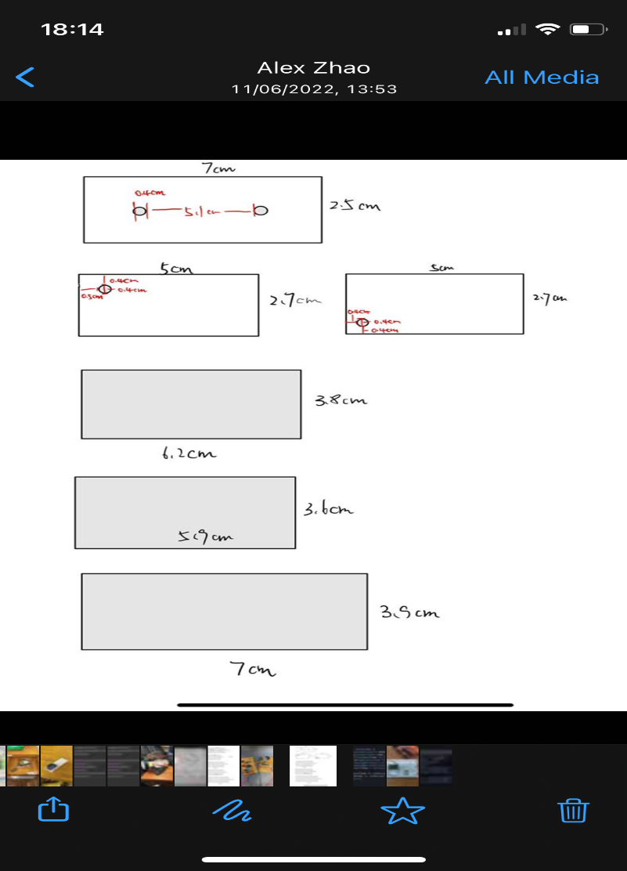

*Fig 1. The size of the stripboards we are using for detecting the signals being emitted by the rocks.*

The top two are for the IR and Ultrasound sensors. Below in order is the Magnetic sensor, Radio 1 sensor and Radio 2 sensor.

The size of these together with the other components would be far too much for the default chassis we had been using in the previous lab skills.

This presented an issue though. If we just made a chassis which could fit all of the components on it side by side. Our rover would become extremely large. This would have repercussions such as a slower overall speed, less manoeuvrability, the potential to crash into other rovers would be greatly increased and it would take a great deal of time to position our rover appropriately to allow the sensors to be in range to detect the signals which the rock is emitting.

There was another issue, this was that some of our sensors needed to be extremely close to the rocks to detect the signals. For magnetic and IR, these ranges were ~2-3cm. This meant that we would have to get the part of them which detected the signal extremely close to the rock.

These problems required two different solutions. One clear thing was we needed to find a way of reducing the size of the chassis so it wasn’t too much of a hindrance to our ability to translocate around the environment. The second was that some of the sensors would need to be placed below the chassis so that they would be close enough to detect the signals.

We went about tackling these problems in a similar way. The solution we present was to overlap some of the sensors due to their differences in size (one above and one below the chassis). This would save space while allowing us to get the Magnetic and IR sensors in range. This meant though, that we needed to have a rover which would be capable of going over the rocks causing us to 3D print our wheels so that they would be large

**The designs we made:**

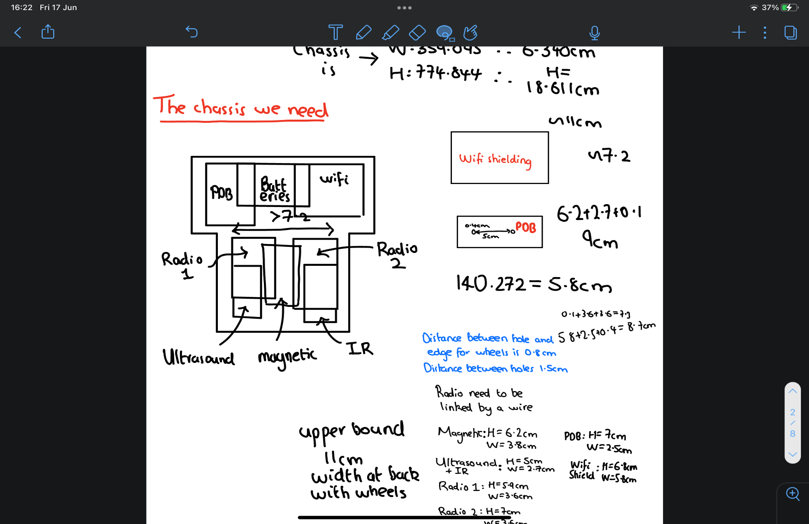The first design had all of the sensors at the front with everything else at the back. One of the things we wanted to do was have the back of the chassis be heavier than the front. This way when the wheels attached to the motors were on at the back, the rover would be more stable and have better traction.

This design was fairly robust however we tried to save slightly more space as we noticed that the power distribution board was slightly thinner than the ultrasound sensor. Since the ultrasound sensor has a range of ~1-1.5m we were comfortable that even if it was at the back, signal detection would not be an issue.

*Fig 2. Our first design formatting of components*

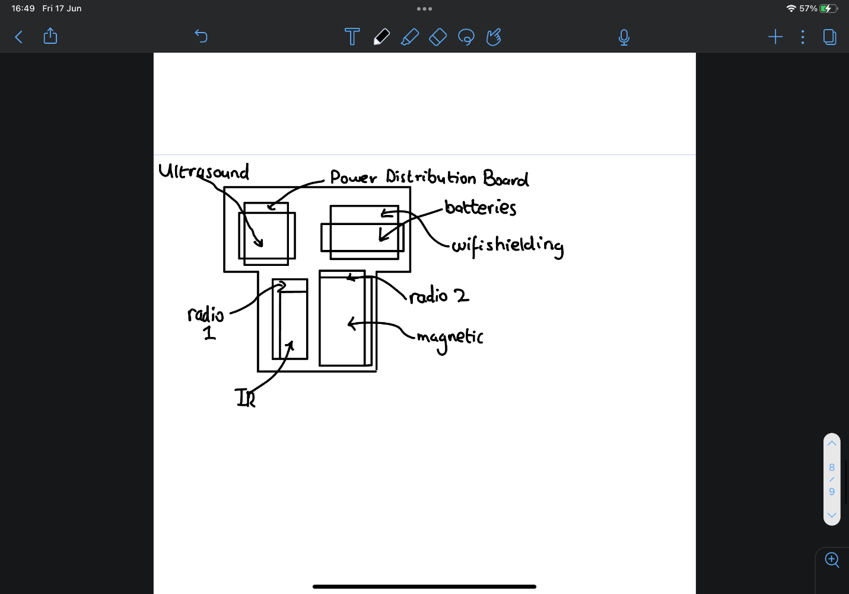

Moving some of the components, further space-saving measures could be obtained. This design relied on our ability to join multiple components together with very little overlap. This presented problems for both the laser cutter being able to precisely differentiate between the holes and also where we could place the holes on our components as there wasn’t very much space on the stripboards.

*Fig 3. The design which now placed the ultrasound sensor underneath the power distribution board*

We had the schematic of the original version of the chassis on GitHub. We used this to know the distances between the holes for the power distribution board, Wi-Fi shielding and the batteries. This also gave us the size of the holes, which were the same size as the ones we knew we would be using for our stripboards. Giving us this design

*Fig 4. Design one. Created using Inkscape*

Similarly to the first design. Non-stripboard components were placed at the back along with the wheels. This also incorporated more symmetry about the chassis in theory making the rover easier to control. Instead of reducing the size, this design went about creating holes in the chassis where we would place certain sensors underneath the chassis.

*Fig 4. Design two. Created using Inkscape*

**The Chassis we went with:**

We printed off both designs.

After both designs were laser cut, we compared their compatibility with the components we were using. When doing this, we came to the conclusion that design two was more suited to our specific needs.

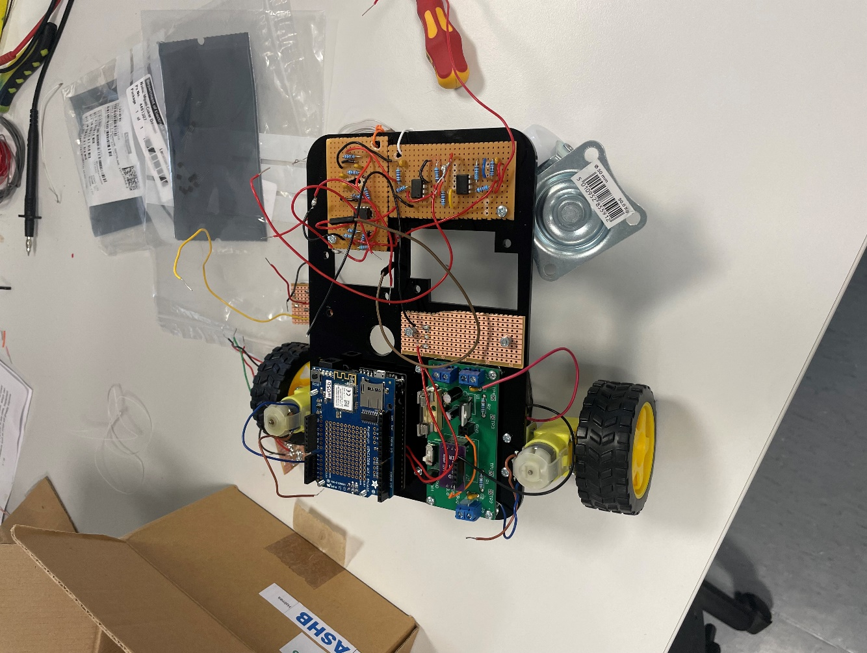

*Fig 6. Photo of Design 2 being assembled into the full rover*